Sebastian Jules – Chef
sohochefcreative@yahoo.com
Tel: [+44 (0) 7807 112702]

Sohochef-creative.com
[British Citizen] [Single] [True non-smoker]

Experience and Personal Attributes

Quality Chef for Hire for your Dream Date or Party - email for details.

I'm Sebastian Jules with years of professional cooking experience. I have a passion for great food and wine. I have a natural flair and ability to work to tight deadlines and produce high quality, interesting menus at short notice. I research selected ingredients based on seasonal quality and have received compliments and positive feedback from guests for newly created dishes. I love classic yachts, diving, the Caribbean, and the forest. I am a keen skier.

Please see my website Sohochef-creative.com

Employment

Freelance chef (2012 - 2018 and 2022 - 2023)
Reed/Blue Arrow/Berkeley Scott/Compass-Group, UK.

- Chef at weddings and catering events at Ashton Court Estate.
- Worked for corporations, a Bupa care home and Montessori schools; pre-school and nursery.
- Hosted parties at private households.
- Actively creating a bio food product as I enjoy good flavours and branding organic Asian superfoods.

Freelance chef for hotel/private households (2019 - 2021)
Lech Hotel/Staff of Distinction/Tiger Recruitment, London.

Head Chef Yacht Experience

Gourmet Chef (2014 - 2017)
- Yacht (24 meters) (one day) Antibes.

- Yacht Cleopatra - travelled the Italian and French Rivieras (57 meters). Short seasonal role, owners’ choice. Yacht catered for 8 guests + 13 crew.

- Yacht Arina - based in San Remo (40 meters). Yacht catered for 11 guests + 7 crew. Inventory was for a 19 day trip and barbecue.

Italian Chef (2013)
- Yacht Commitment of London - chef for a few days before charter was cancelled. Yacht was based on the Italian Riviera (40 meters), catering for 7 crew. I prepared an Italian menu and inventory.

Gourmet Chef (2009 - 2010)
- Yacht Shootin’ The Breeze - based in Villefranche (37 meters). Short seasonal role, owners’ choice. Yacht caters for 12 guests + 5 crew. I also catered at their Villa. (1 month)

- CHEF/STEWARD Yacht Blooms - based in Monaco (33 meters). Short seasonal role, owners’ choice. Yacht charters regularly and caters for 12 guests + 2 crew. (6 weeks)

- Yacht (50 meters) (one day) Monaco.

The summer yacht Rivera season can be stressful. During my day as a chef, I make practical judgments that keep the crew happy as well as executing gourmet food. I also travel to Rome often to shoot new collections of food photos to promote menus. Day rate €300/600+ and small yachts monthly €6000. Photographs of the yachts I’ve been on are on my Instagram acc. Own room preferred.

Chef (2010 - 2011)

ASK Restaurant, UK Specialises in Italian food.

The Brighton Centre, UK (Up to 75 servings) (temporary position)

Managerial Employment

Stage Manager - Mediterranean (short contract)
G&P Ships Contractors Co - IT (2009) (medium sized cruise ship)

Overseeing position - Chateau, Nice, France (2007 - 2009)
My duties included cooking, service, and household management. The cuisine was Mediterranean/Italian/Chinese cooking, service of meals and setting of tables/miscellaneous duties for many people.

Manager of staff/therapists – The Secret Spa (2006)
During my experience, I used multi-tasking and problem-solving skills whilst maintaining a professional approach and friendly attitude clients and customers. I was responsible for 7 staff, supplies/accounts.

Accounts Executive and Event Co-ordinator (2003) (part-time)
My duties included creating/organising accounts, business plans and special events, supervised events and employing staff.

Cafe Manager/Chef - N.Y. (2000 - 2003)
I created menus, organised accounts, 5 staff and supplies.

Courses/Training | Exam Results | Dates
STCW/Security Awareness/Crowd Management/ENG1 | Issued in Naples, Italy
MSc Food Biotechnology Master’s Degree/UoL | Pass | 2022
Food Safety & Hygiene For Catering Level 2 | Pass | 2018
Law LLB 3 year Degree/UoL | Second | 2018
Access to HE Diploma Combined Studies | Pass/Merit | 2012
Diet & Nutrition course | Pass | 2011

Interests and Achievements

I have worked in French restaurants (inc. Le Panache, NYC) (Silver Service/Fine Dining).
Feng Shui Interior Design Stanmore College, London. I have produced work projects.
Ship’s cook Practical Cookery Level 2 NVQ material studied.

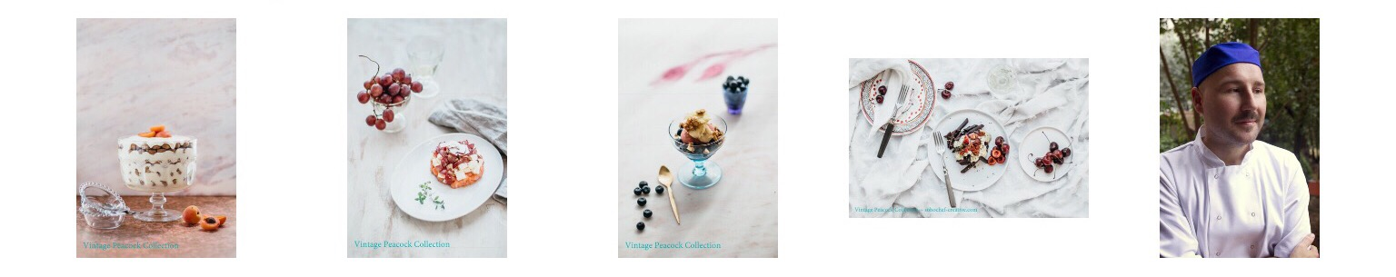

COVER LETTER

‘The 1% Chef’.
Brie et Basilic brochure
static1.squarespace.com/static/54b921c6e4b013117dffb722/t/5a0c7cff652dea776acd28ed/1510767923590/brochurecompressed_edit.pdf

I'm Sebastian Jules and in the culinary arts, I am the creator, manager, and chef of my own elite catering company. I am an accomplished food designer with years of experience in the field of making exceptional food. I have worked in yachts, restaurants, private mansions and my key areas of expertise include, but are not limited to the following;

A solid background in visual design, and artistry. Having a reputation for cooking and design. Possessing a convincing track record of experience in management, teaching, singing and lots more. I have a proven track record of responsibility, integrity and commitment and I am comfortable working independently and as part of a team.

My cuisine is Mediterranean, Italian and Fusion (Spanish-Lebanese) and I’m trilingual (English/French/Spanish). I've travelled extensively and after leaving college, I started dance training in Japan and with Rambert Ballet BA. My classical career ended in 2008; afterwards I produced music and concentrated on cooking and design. I've written Chamber Opera, a yoga book, and produced a CD - Sassy ça but food is where passion lies. All my dishes are photographed in Italy (approx. 150). My focus is less meat/wheat, better dairy choices, organic, alkaline, and sustainable seafood. Shall we speak about the exciting food?

Thank you for taking the time.
Best Regards, Sebastian Jules
Sohochef-creative.com

44 (0) 7807 112702
Instagram - jules.sebastian
Skype - live:bestbighouse

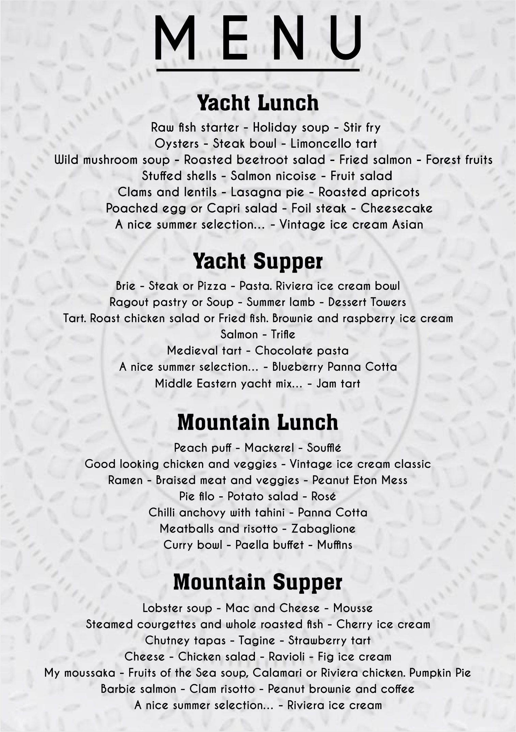

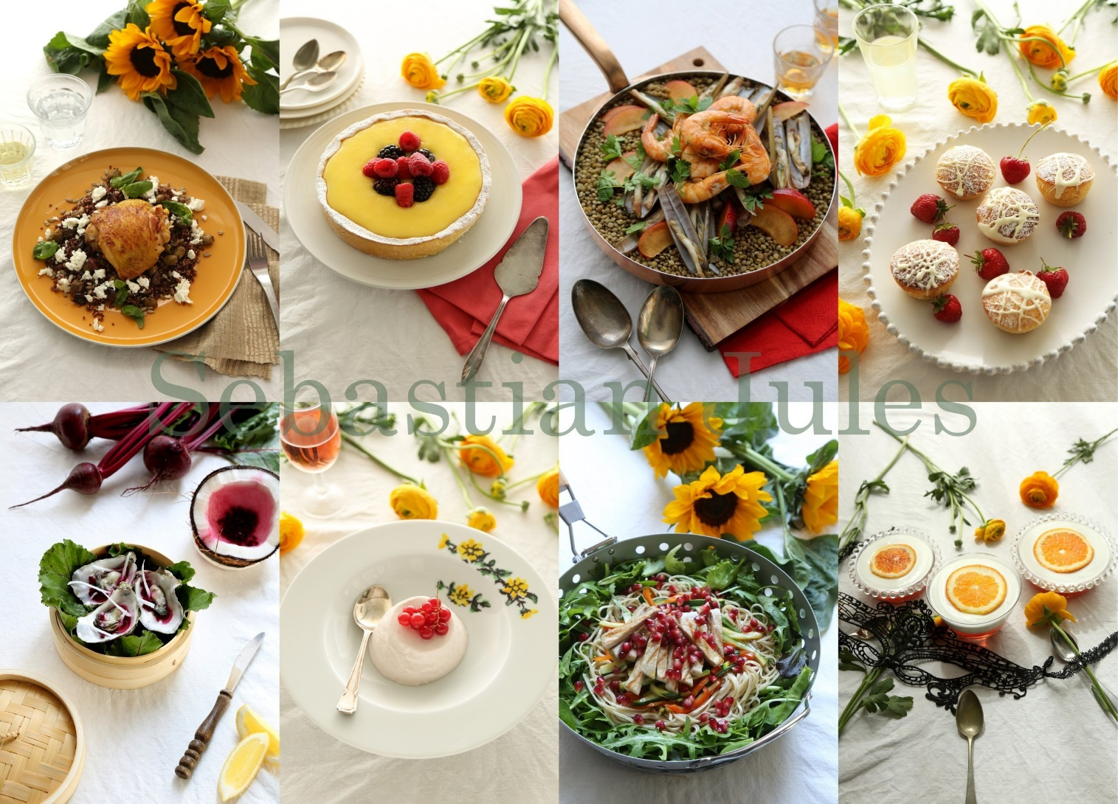

Please see my website Sohochef-creative.com

